UNCG

**Design Document**

**Digital Billboard**

Abstract

The Digital Billboard streams up-to-date web content based on the system configuration to access web sources.   
Other sources of information can be added.

Author

Charles Brady, System Analyst

Table of Contents

1 Introduction 1

1.1 System Description 1

1.2 References 1

1.3 Dependence, Assumptions, Risks & Constraints 1

2 Architecture 1

2.1 Architecture Diagram 1

2.2 Programming Language 2

2.3 Database 2

2.4 Infrastructure 2

3 Detailed Software Design 2

3.1 UML Diagram 2

4 Reviewers 3

5 Appendix 3

5.1 Supporting Documents 3

5.2 Revision History 3

# Introduction

## System Description

The Digital Billboard streams up-to-date web content based on the system configuration to access web sources. Other sources of information can be added via the administration module.

## References

* System Requirements Document is a separate document.
* UML Class Diagram is contained in a separate document.

## Dependence, Assumptions, Risks & Constraints

* A computer monitor is an acceptable resource to serve as the digital billboard display.
* Web content will be available for testing and demonstration of the solution.

# Architecture

The Digital Billboard will be built on the LAMP stack. LAMP stands for Linux, Apache web server, MySQL database, and Perl, Python or PHP. LAMP was selected because it is a powerful solution that is simple and easy to use. In addition, LAMP’s components are open source, meaning that they are freely available.

## Architecture Diagram

Below is the architecture Diagram for the Digital Billboard system, showing the LAMP architecture, the web content data source, and the digital billboard display.

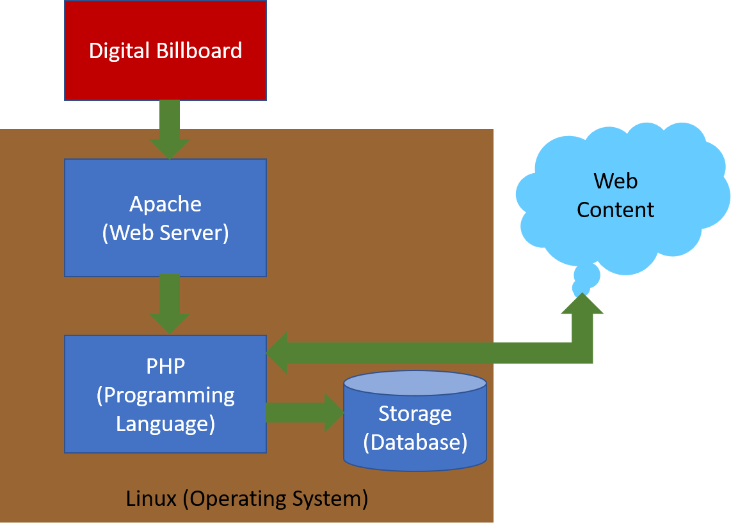

## Programming Language

The Digital Billboard system will be developed using PHP.

## Database

The sources of web content are maintained in a text file, which will serve as a textual database. Sources are added via the administration module.

Instead of MySQL, the Digital Billboard was developed using a text database (TextDB) as storage. This was selected because of the limited amount of data that is required for the solution (name, path, type, and URL). Since only one table was required, a relational database was not required.

## Infrastructure

GitHub provides the infrastructure for this Digital Billboard system.

# Detailed Software Design

## UML Diagram

The UML diagram is in a separate file due to size. The UML diagram depicts the Database, Interfaces, Controller, Views, Translators, Utilities, Models and Templates.

* Database – maintains a list of web content sources.
* Interfaces – contains a connector that connects to the web content data source.
* Controller – is the administrative model that allows the administrator to add, edit, delete, and update web content sources. In addition, the list of available sources can be displayed, and the source to be displayed can be selected.
* Views – displays the web content using the appropriate template file.
* Translators – uses database information to map the source content to the correct model.
* Model – displays data differently depending on the source content. There is a base model for all content and special models for different types of content.
  + News Post – displays date/time, URL, and news content
  + Instagram® – displays image, thumbnail, and content
  + YouTube® – displays video content
* Templates – provides templates for news posts, Instagram®, and YouTube® display.
* Utilities – handles errors

# Reviewers

|  |  |  |
| --- | --- | --- |
| Name | Position | Date |
| Mikael Williams | Developer |  |
| Michael McCulloch | Team Lead | 12/2 |
| Jacob Oleson | Developer |  |

# Appendix

## Supporting Documents

System Requirements Document

UML Diagram

## Revision History

|  |  |  |  |
| --- | --- | --- | --- |
| Version # | Date of Change | Summary of Change | Author |
| 0.1 | 11/01/2018 | Initial Version | Charles Brady |
| 1.0 | 11/23/2018 | Incorporated team comments | Charles Brady |
| 1.1 | 12/4/2018 | Incorporated team comments | Charles Brady |